**10 SCIENCE BIOLOGY ASSIGNMENT: GENETICALLY MODIFIED CROPS 2016**

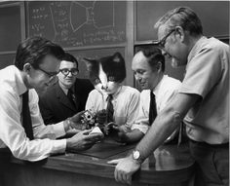

Name:__________________________ Teacher: Miss Cerny

Form:__________________________ Due date: ____________________

**Aim:** This assignment will allow you to research information about genetically modified food.

**Hint:** chapter 1.4 of your e-book has information you can use and then reference. I have also attached two pages of information you can read.

**Plagiarism:**

You must write in your **own words** not copy sentences word for word from another student or another source.

Plagiarising = instant zero on assignment and you will have to re-do it.

**Assessment policy:**

Give me a sick note/legitimate reason from parent BEFORE due date = new negotiated due date.

One day late = -20% taken off mark

Two days late = -40% taken off mark

Three days late = mark of zero given, students are required to attend a detention and are still required to submit the assignment.

**If you are not at school the day this assignment is due, please email it**

**to me by 4pm.**

**s.cerny@aranmore.wa.edu.au**

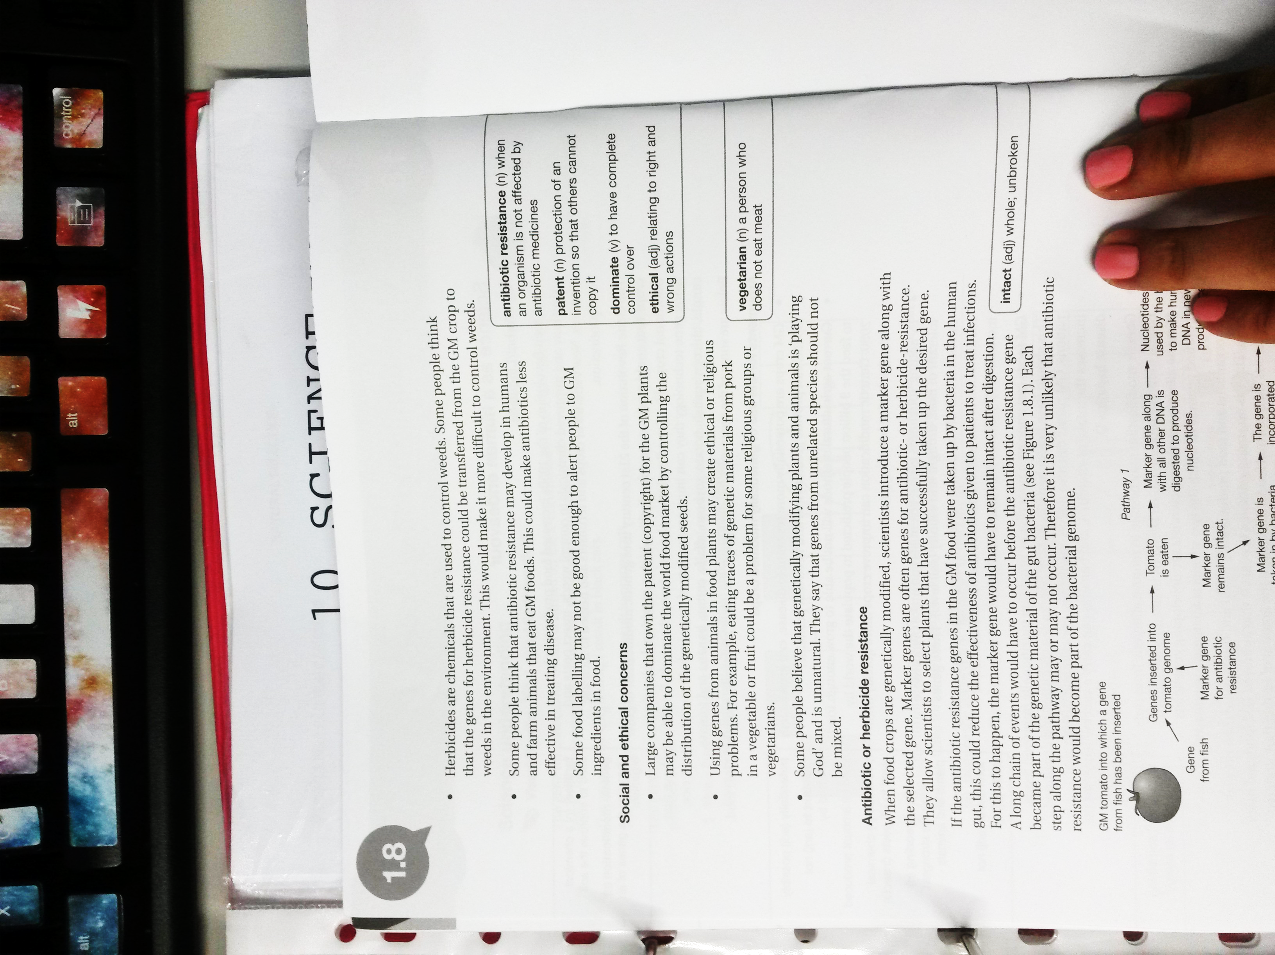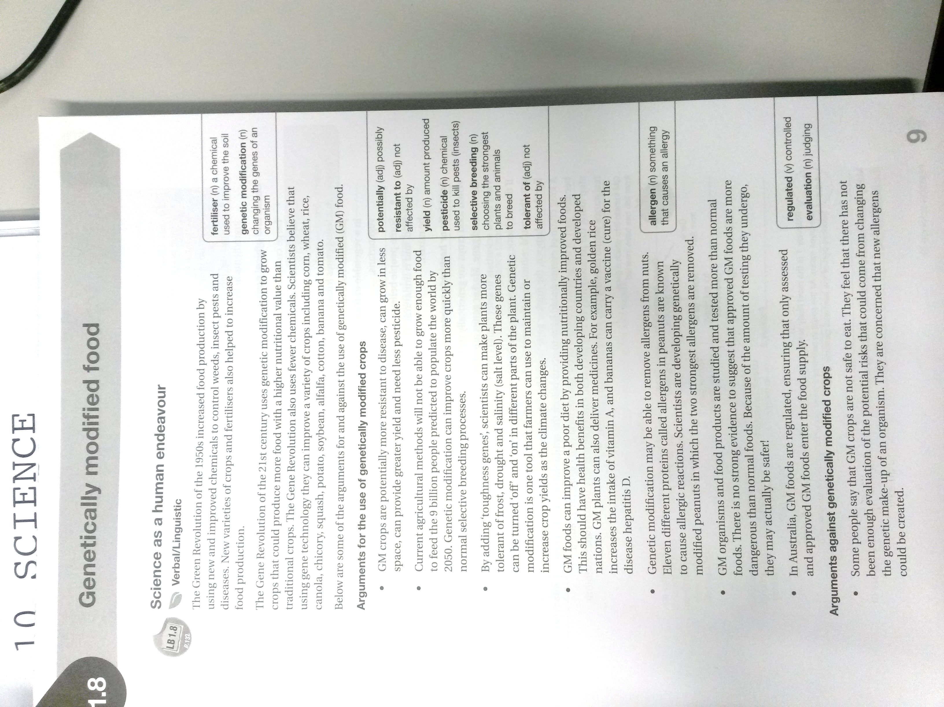

1. In your **own words**, and in language you understand, write a paragraph (minimum 3 sentences) that **explains** what genetic modification is. (3 marks)

_________________________________________________________________________________________________

_________________________________________________________________________________________________

_________________________________________________________________________________________________

_________________________________________________________________________________________________

_________________________________________________________________________________________________

_________________________________________________________________________________________________

_________________________________________________________________________________________________

_________________________________________________________________________________________________

_________________________________________________________________________________________________

**Choose either GM canola OR Golden rice**

Name of your GM crop: _______________________________________________

2. **Explain** how your chosen crop has been modified (changed).

What is a characteristic that is has now that it didn’t have before it was modified? (2 marks)

_________________________________________________________________________________________________

_________________________________________________________________________________________________

_________________________________________________________________________________________________

_________________________________________________________________________________________________

_________________________________________________________________________________________________

_________________________________________________________________________________________________

_________________________________________________________________________________________________

_________________________________________________________________________________________________

_________________________________________________________________________________________________

_________________________________________________________________________________________________

_________________________________________________________________________________________________

_________________________________________________________________________________________________

4. **Describe** two advantages of genetically modifying your **chosen** crop (in full sentences). (2 marks)

_________________________________________________________________________________________________

_________________________________________________________________________________________________

_________________________________________________________________________________________________

_________________________________________________________________________________________________

_________________________________________________________________________________________________

_________________________________________________________________________________________________

_________________________________________________________________________________________________

_________________________________________________________________________________________________

5. **Describe** three benefits of GM crops in general (***not including*** the benefits you described in question 4). (3 marks)

_________________________________________________________________________________________________

_________________________________________________________________________________________________

_________________________________________________________________________________________________

_________________________________________________________________________________________________

_________________________________________________________________________________________________

_________________________________________________________________________________________________

_________________________________________________________________________________________________

_________________________________________________________________________________________________

_________________________________________________________________________________________________

_________________________________________________________________________________________________

_________________________________________________________________________________________________

_________________________________________________________________________________________________

_________________________________________________________________________________________________

6. Some groups of people are against genetically modified crops (anti-GM). **Describe** three claims these groups of people make against GM crops and for each one explain whether or not you think it is valid (rational, justifiable) and **explain** why/why not. (6 marks)

Claim 1: _________________________________________________________________________________________

_________________________________________________________________________________________________

_________________________________________________________________________________________________

_________________________________________________________________________________________________

_________________________________________________________________________________________________

_________________________________________________________________________________________________

_________________________________________________________________________________________________

_________________________________________________________________________________________________

_________________________________________________________________________________________________

Claim 2: _________________________________________________________________________________________

_________________________________________________________________________________________________

_________________________________________________________________________________________________

_________________________________________________________________________________________________

_________________________________________________________________________________________________

_________________________________________________________________________________________________

_________________________________________________________________________________________________

_________________________________________________________________________________________________

_________________________________________________________________________________________________

Claim 3: _________________________________________________________________________________________

_________________________________________________________________________________________________

_________________________________________________________________________________________________

_________________________________________________________________________________________________

_________________________________________________________________________________________________

_________________________________________________________________________________________________

_________________________________________________________________________________________________

_________________________________________________________________________________________________

_________________________________________________________________________________________________

7. **Decide** whether you support the continued use of GM foods in Australia and **justify** your decision (explain why). (2 marks)

_________________________________________________________________________________________________

_________________________________________________________________________________________________

_________________________________________________________________________________________________

_________________________________________________________________________________________________

_________________________________________________________________________________________________

_________________________________________________________________________________________________

_________________________________________________________________________________________________

_________________________________________________________________________________________________

8. Look at the following groups in Australia and state whether they are for growing GM crops in Australia or against growing GM crops in Australia. For each group, write a **quote** you found on the website that supports your answer. (8 marks)

|  |  |  |
| --- | --- | --- |
| Group | Pro-GM or anti-GM | Evidence to support your answer |
| Crop Life Australia  www.croplifeaustralia.org.au |  |  |
| Biotechnology Industry  Organization  http://www.bio.org/ |  |  |
| Producers Forum  www.producersforum.net.au |  |  |
| True Food Network  [www.truefood](http://www.truefood).org.au |  |  |

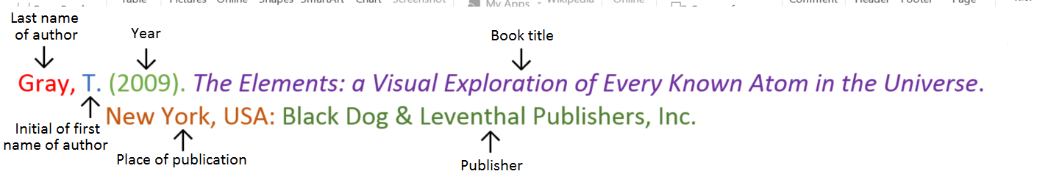**Book**

**Book with two authors**

Shermer, M., & Benjamin, A. (2006). *Secrets of Mental Math: The Mathemagician’s Guide to Lightning Calculation and Amazing Mental Math Tricks*. New York, USA: Three Rivers Press.

**Book with three or more authors**

Bulliet, R. W., Alley, R. B., Broecker, W. S., & Denton, G. H. (2011). *The fate of Greenland: Lessons from abrupt climate change*. Cambridge, MA: MIT Press.

**Book with editor**

Kasdorf, W. E. (Ed). (2003). *The Columbia guide to digital publishing*. New York, USA: Columbia University Press.

**Book with different editions**

Nagle, G., & Cooke, B. (2012). *Geography Study Guide: Oxford Ib Diploma Programme* (2nd ed.). Oxford, UK: Oxford University Press.

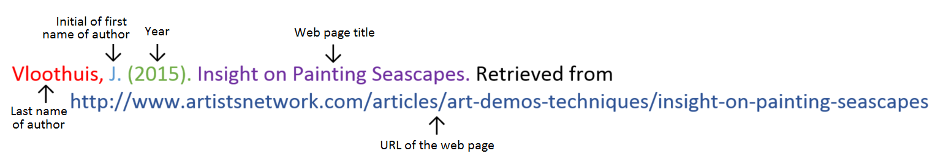**Website**

**Website with no author** (put title of page at the front)

Aranmore Catholic College. (2014). Retrieved from

http://www.aranmore.wa.edu.au/

**Website with no date**

The Zadkine Museum. (n.d). Retrieved from http://www.france.fr/en/museums/zadkine-museum.html

**Video file**

**Reference list**

Minimum of two references. (1 mark)

Minimum of two different sources (1 mark)

(Book, encyclopedia, video, website, journal, magazine, newspaper).

Referenced using the APA style on the previous page. (1 mark)

_________________________________________________________________________________________________

_________________________________________________________________________________________________

_________________________________________________________________________________________________

_________________________________________________________________________________________________

_________________________________________________________________________________________________

_________________________________________________________________________________________________

_________________________________________________________________________________________________

_________________________________________________________________________________________________

_________________________________________________________________________________________________

_________________________________________________________________________________________________

_________________________________________________________________________________________________

_________________________________________________________________________________________________

_________________________________________________________________________________________________

Assignment is neatly written or typed. (1 mark)

Correct grammar and spelling. (1 mark)

**Total mark: /31 %**

**Teacher comments:** on Seqta